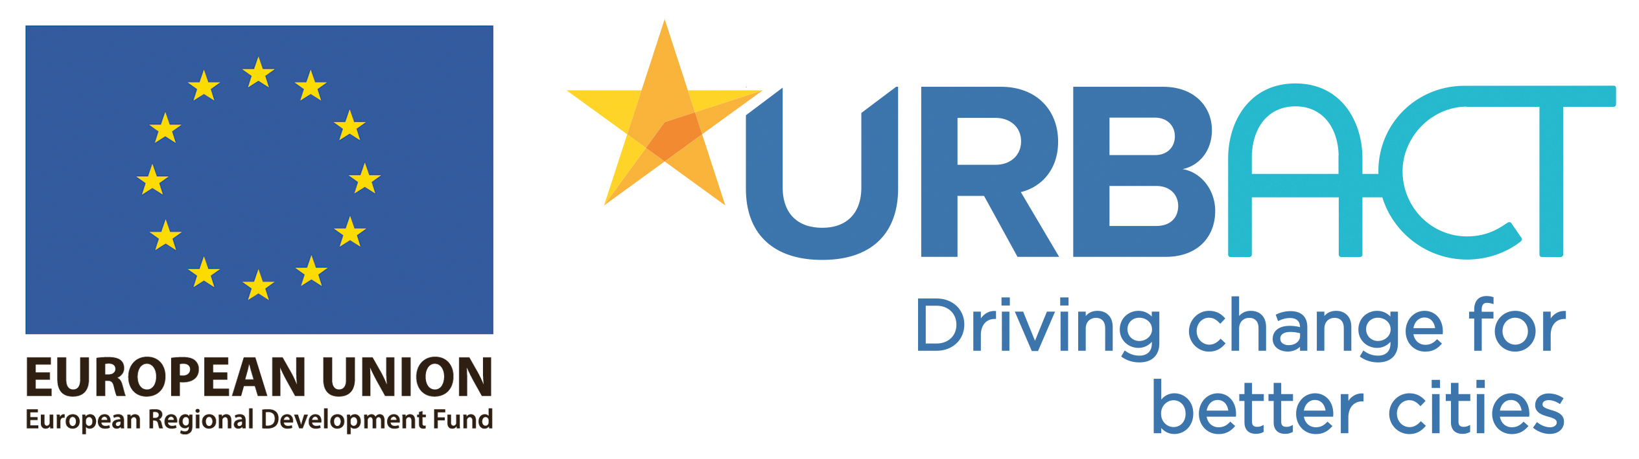

***TECH REVOLUTION 2.0***

**Transfer Roadmap**

**in *RZESZÓW***

TABLE OF CONTENTS

**SECTION 1: Introduction and policy context** 3

1.1: Introduction and city profile 3

1.2: Needs analysis in the territorial context 6

**SECTION 2: The URBACT Good Practice** 8

2.1: The Good Practice in summary 9

**SECTION 3: Our starting Point** 11

3.1: The local challenge and how we have addressed it 11

3.2: Our motivation 15

3.3: Our Assets and barriers 16

**SECTION 4: Our Network transfer model** 17

4.1: The Network methodology 17

4.2: Our local level activity 19

4.3: Our role in the transnational level activity 22

**SECTION 5: The scale of our ambition** 22

5.1: Our aspiration 22

5.2: Risk assessment 23

## SECTION 1: Introduction and policy context

### **1.1: Introduction and city profile**

**CITY OF RZESZÓW**

**MIASTO RZESZÓW**

* Province: **Podkarpackie**
* Area: **130 km2**
* Number of citizen: **approx. 200k / The upward trend**
* Unemployment rate: **approx. 5%**
* Number of students: **approx. 40k**
* Average citizen age: **39 years**
* Main economy branches: **Aerospace, IT**

Location of Podkarpackie region with its capital - City of Rzeszów

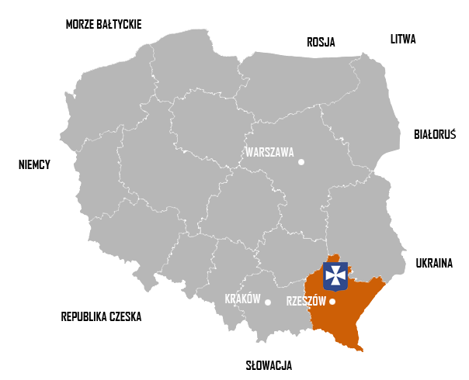

Main road network in the Podkarpackie Region around City of Rzeszów (A4 motorway and S19 Express way)

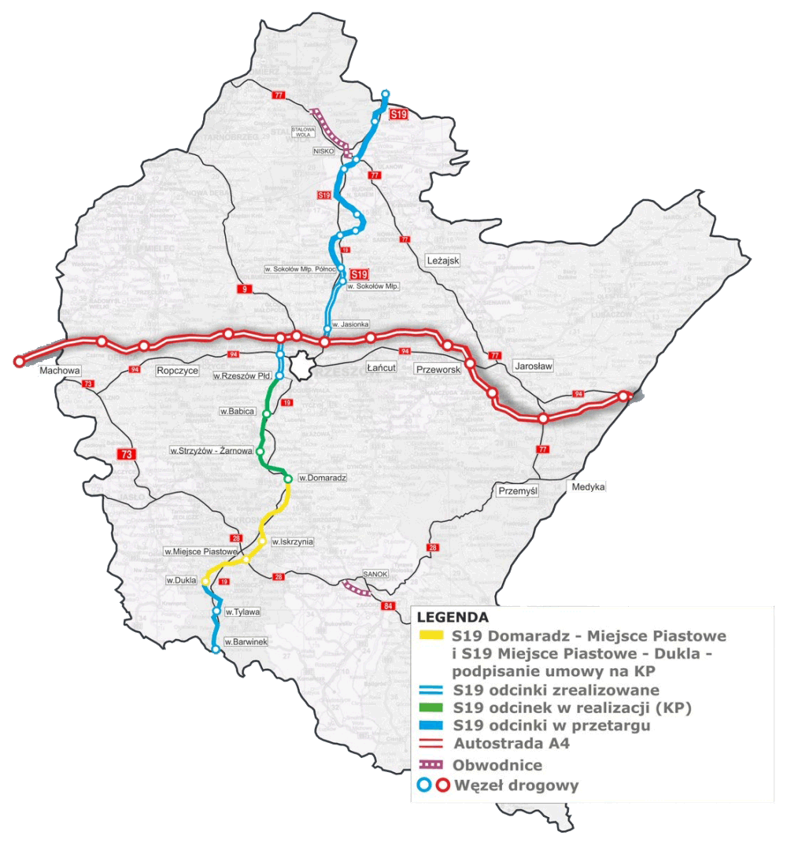

Rzeszow is the biggest town in the Podkarpackie Region and the administrative centre   
of different levels but it is also a significant centre of education, culture, science, industrial production and services in general. Thus, Rzeszow offers the biggest and the most diverse labour market in the Podkarpackie region. This is much more than the value for the Podkarpackie Region and much more than the value for Poland, 49.5% of active are women. Registered unemployment in Rzeszów was 4.8% in 2019 (5.1% among women and 4.5% among men). This is much lower than the unemployment rates for the Podkarpackie Region and less than the registered unemployment rates for the whole of Poland. In 2018, the average gross monthly salary in Rzeszów was PLN 4,802.41, which corresponds to 99.30% of the average gross monthly salary in Poland.

Rzeszów is easy accessible city - several important tracks intersect in here. Rzeszów   
is one of the biggest university centres in Poland. On five universities educate together nearly 60 thousand students at 60 various fields of study. Rzeszów is also home to several innovative clusters, such as "Aviation Valley Cluster" – concentrated on rapid development and growth   
of the aerospace industry; „Eastern Poland IT Companies Cluster” – responsible for consolidation and cooperation of IT companies; well-developing „Cluster of Unmanned Systems” – engaged in the development of drones and other flying systems; „POLIGEN Cluster” – affiliating institutions involved in plastic processing; „Subcarpathian Renewable Energy Cluster” – focused on development of the environmentally friendly power industry based   
on renewable energy sources or The Life Quality Cluster „Podkarpacie Country”.

Rzeszów is a global leader in the manufacture of products for aerospace, energy and construction, and a supplier of engines for jet aircraft. In order to create favuorable conditions for doing business in Rzeszów, the City Authorities decided to establish an economic activity zone „Rzeszów-Dworzysko”. In addition, the City of Rzeszów applies the exemption from property taxes, which is a regional investment aid for entrepreneurs creating new jobs associated with new investments in the city.

Three main drivers for new technology and economy growth are higher level education, regional smart specialization combined with growing start-up ecosystem.

Well organised higher education is one of the main factors development of the City. High number of students which fluctuate around 50k. on technical universities as Rzeszów Technical University and University of Information Technology and Management, create perfect conditions for the creation and development of technology enterprises in the city and region and provide staff for such enterprises that are looking for a place to invest and create their companies and branches, conditioning it with access to staff with appropriate education.   
An element derived from a well-developed academic community is a very young society, with an average age of 39, which causes a general increase in technological awareness in the local community as well as greater willingness and flexibility to take risks in creating modern enterprises in new technologies.

The second key factor of new tech and digital economy development is placing increasing emphasis on smart specialization by European Commission as a development tool for regional development. This is an approach that aims to boost economic growth and employment   
in Europe by identifying and developing their own competitive advantages of the regions. This term is present it is in many strategic EU documents, including Horizon 2020, which   
is a financial instrument implementing the Innovation Union, aimed at ensuring the global competitiveness of Europe, i.e. the strategy for for smart and sustainable development. Smart specialization connects the environment of local authorities, academia, business and civil society working for implementation long-term growth strategies supported by EU funds.

Smart specializations for the Podkarpackie Region, which currently are Aviation and astronautics and most important Information and telecommunications (ICT). with regional and European support is one of the biggest driver to boost local economy development and digital transformation of the city and region. Big High Tech companies derived from region as Asseco Polland or Soft System combined with high level of education and perfect condition for developing ICT companies are strong drivers for digital economy implementation and development.

Recognition of the ICT industry as one of the four smart specializations of the region causes investments and projects implemented in this area have priority in terms of EU funding development programs, both in the ending 2014-2020 perspective and in the new one for 2021 - 2027, as well as within the framework of systemic activities of national authorities.

### **1.2: Needs analysis in the territorial context**

A city which wants to stay in the global economic race, in dynamically changing macro, microeconomic, social and cultural conditions, must produce an efficient system of support for the local SME’s ecosystem that are the backbone of the local economy.

The COVID-19 pandemic, which shook entire economies of the world's largest powers, showed that in the face of such a great threat, a key element survival is the flexibility of local business ecosystems, which are able to efficiently and quickly adapt to even the most extreme changes on the market, ensuring increased resistance to drastic cuts in the labor market, permanent building of innovative know-how, continuous provision of services and goods with their efficient adaptation to a dynamically changing environment.

A well-developed ecosystem of local eterprises, especially those important for the development of the digital economy and the implementation of innovative solutions on a global scale,   
is a significant element of the resilience of the entire city and region to economic turmoil and unpredictable situations.

As a medium-sized city in comparison to other regional cities, Rzeszów is facing an increased competition for every inhabitant. Building favourable conditions for small and medium-sized business is one of the many factors that keep young educated people in the city. This is even more of a challenge at a time when young people are very mobile and ready to leave the country to go outside the city or country in search of better working conditions and life.

Due to the traditions in the field of the aviation industry dating back to the 1930s, and the concentration of large technology companies from the aviation industry in the city and the county, for many years Rzeszów has focused its attention on acquiring large investments related to the aviation industry and developing favourable conditions.

As a further plan of taking advantage of the economy main branches, city will intense its efforts to structuring support system to create even more favourable condition to attract big investors as well as supporting SMEs related to new technologies and aviation industry. Very important part of the system will be post – investment support, which will create long standing relation between business and city administration.

The city administration, with its human resources, budget, high social trust and network   
of contacts, has the potential to take the role of a key player in the active development of the business support ecosystem and creating the ground for the development of innovation on local ground. Building such a system must be based on the needs reported by entrepreneurs and residents, so that the implemented activities and the offered tools and public services respond to them accurately and provide conditions appropriate for the development   
of enterprises.

Another challenge for the city is to build an efficient business support system, which will consist of many tools, however, operating as a coherent and effective whole. Considering the complexity of the urban ecosystem and the complexity of urban structures, this is also   
a challenge that must be overcome.

Another challenge faced by the administration of many cities is changing the image of the city as a public administration, in which only the necessary formalities are handled and documents for such an institution that actively supports residents and entrepreneurs and is a place open to dialogue is another factor. The ability to view experiences at the leader and all partners   
of the Tech Revolution project, provides an opportunity for transfer and implementation   
of proven and effective solutions building the image of the City as a meeting point for all social and business groups open to dialogue and ideas of every resident.

The need to build and develop a support system for business, in particular for young people and innovative enterprises can be presented in the form of a general list of challenges that the city is facing in the near future:

* Non –existing one-stop shop support for business within city office structure
* Weak or no-existing cooperation inside the city office structure in the field of providing business support
* Diffused and chaotic data / information, relevant to the local business in the city administration
* Limited focus on local innovative startup’s and digital businesses as measure for local development
* Weak (or non-existent) digital business community support in the city
* Lack of regular or very selective contact with local business in wide range of its size
* Lack of effective and efficient communication strategy focused on economy development and digital business.
* Lack of regular events calendar related to business development as possibility to networking, talent search, pitch sessions, relation tightening, market research…etc.

## **SECTION 2: The URBACT Good Practice**

### **2.1: The Good Practice in summary**

The Good Practice was developed by Barnsley over more than 12 years and comprises two main pillars:

1. a business support programme - Enterprising Barnsley and
2. a landmark hub for creative and digital business - the Digital Media Centre, established in Barnsley’s town centre.

Enterprising Barnsley: Initially funded through ERDF and subsequently by the Council, Enterprising Barnsley provides an integrated package of intensive support focused on local (start up and established) business needs in order to create and accelerate economic growth. The portfolio of projects focuses upon business start-up support, business incubation, enterprise coaching, inward investment, business grants, property support, networks and workshops and enterprise hubs.

The DMC: a landmark of creative and digital businesses with office accommodation located in a unique environment.

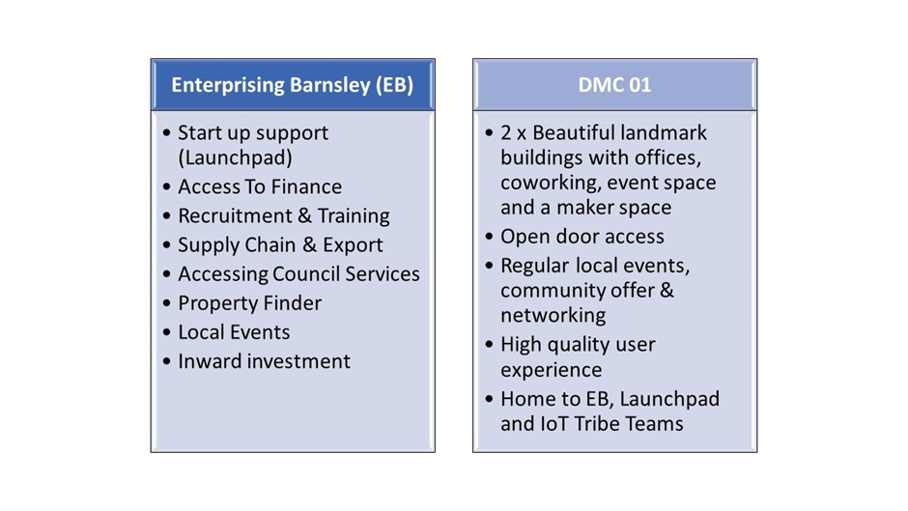

The Good Practice has been developed and delivered over a period of 12+ years. Building on the lessons of the first Transfer Network, this second wave will help a further  
4 towns and cities, encluding Alytus city, to learn from a wide range of council staff and local stakeholders what works and what doesn’t when it comes to supporting tech and digital companies to survive and grow. It will prevent our wave cities from making some of the mistakes that have been made in Barnsley. It will help us to develop the networks, skills, knowledge and ambitions needed to create the conditions from which a digital and tech ecosystem can grow. It will help us to identify local digital champions and to engender the buy-in and support needed to drive this agenda forward. It will provide us with detailed information on a large number of interlinked projects and processes which, takentogether, constitute the Good Practice.

Good DMC practice and the entire ecosystem created in Barnsley is an excellent reference point and an example of systemic implementation of supporting local entrepreneurs, especially those focused on innovation and digitization of the economy.

In connection with the activities already undertaken in Rzeszów, which are aimed at creating an effective business support system and the creation of the URBAN Lab, which was   
a pilot project to test solutions for "opening" the city to residents and involving them in decision-making processes, good practice will be an excellent point of reference and inspiration to implement its elements in order to further develop the system in Rzeszow.

Due to the fact that Good Practice in Barnsley has been developed for several years, it is not possible to transfer its main elements during the project implementation period. This requires significant financial outlays and a long time to implement them. But there are elements of Good Practice that may be implemented in a short time and successfully tested in Rzeszów.

**DIGITAL MEDIA CENTER** - physical space, co-working and training space and administration, which is at the heart of the entire Barnsley program. It is an inspiration for the development   
of the existing URBAN Lab functioning in Rzeszów, a space that was created as a pilot project to test solutions for "opening" the city to residents and including them in decision-making processes, the good practice will be an excellent point of reference and inspiration to implement its proven elements in order to further develop the system in Rzeszów.

DMC, is a guide of activities and tools proven in practice that will allow to draw effective plan of URBAN Lab development especially the part focused on activities to support system for business in wide range of its size and branches, in particular those operating in the area of new technologies, innovative solutions and creative industries.

**KEY ACCOUNT MANAGERS** - a system of dedicated caregivers whose main task is direct contact with entrepreneurs. Individualized approach to local business allows to mainly build lasting relationships based on trust. They are extremely valuable in terms of cooperation in various areas.

This approach also makes it possible to study the mood in the local business environment, their needs, problems and challenges they face, or urban solutions that may facilitate their functioning. (e.g. appropriate adaptation of urban transport, organization of events allowing for networking of various environments or associating the academic and business environment in order to build a local job search system and employee)

Thanks to this approach, the city actively and effectively uses its potential in order to adjust the implemented tools and activities corresponding to the needs of the local SME ecosystem.

Elements in this area, which to a large extent have already been implemented as part   
of previous activities, and which will certainly be further developed include:

* Access to information from to market
* Links to relevant local schools, colleges, universities and community groups, local recruitment agencies or layoffs
* Support large-scale recruitment through networking and collaborations with academic institutions
* Contact local providers of training, programs and skills sectors
* Networking with professional, accredited and individual training solutions for all levels of the workforce
* Organization of regular networking events

**STARTUP SUPPORT** **SYSTEM** *(LAUNCHPAD)* - a support system for local initiatives at the stage of creation (startup). A delegated, prepared skilled team and tools to support every resident by series of different events, looking for an opportunity to develop an innovative business. The most important elements of this solution that can be implemented in the first stage of building   
a business support system in Rzeszów are:

* A selection of workshops, events and conferences covering key topics
* Networking events to share experiences and obtain peer support
* Data available that provides answers to commonly asked questions with access   
  to Business Planning tools and links to key websites and other important information
* The opportunity to inter-trade between clients

**URBACT PROJECTS INVOLVEMENT -** the history of the development of DMC and the entire Barnsley support program, shows what benefits for the city and what potential participation brings in projects implemented under the URBACT program. An important part of the transfer

good practice under Tech Revolution 2.0 will be the implementation of activities aimed at active involvement in the implementation of subsequent projects. The opportunity to gain experience and knowledge as a partner of the URBACT Transfer Network project will allow for the effective implementation of subsequent projects in the city.

**EXCHANGE OF EXPERIENCES** Apart from the transfer of solutions implemented at the project leader, the added value is also the possibility of exchanging experiences with all project partners. It is important as it allows for the exchange of experiences, analysis and testing   
of many tools implemented in similar areas related to building the digital economy. and support systems for local SME ecosystems but in a completely different environment and local context in each of the partners, which will allow for their even more effective implementation.

## **SECTION 3: Our starting Point**

**3.1: The local challenge and how we have addressed it**

Rzeszów operates on the basis of many strategic documents, including the Development Strategies of the City of Rzeszów until 2025, one of the sector goals of which is "Smart City - Creating favorable conditions for the development of Rzeszów as an attractive place for business and development of education, higher education, science and culture ".

The implementation of the project goals of the Transfer Network fully complies with the strategic goals of the city's development and enables the exchange of experience in the field of tools that have already been implemented or are in the process, which will allow for their more effective implementation.

The system of support for entrepreneurs and economic promotion of the city will be built

based on several key elements. An important element in this process will be the already functioning urban space of URBAN Lab.

The concept of the urban lab was created at the Institute for Urban and Regions Development (IRMiR) as a response to the lack of an instrument supporting cooperation between various groups of urban stakeholders, including primarily the city office and residents, in Polish cities.

The developed urban lab model was based on the concept of a quadruple helix (QH), which describes a scheme of innovative cooperation in which users (residents), business representatives (private sector), universities (scientific institutions) and authorities (public sector) cooperate in the purpose of producing innovation in the form of new knowledge, technology, products and services as well as organizational solutions.

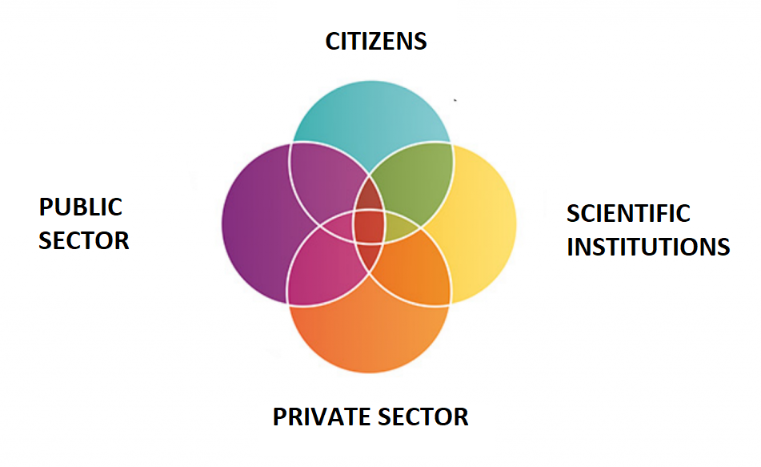

On the basis of the above-mentioned concept, a document was prepared in Rzeszów entitled "Adaptation of the Urban Lab concept in Rzeszów" (for the period 2019-2021) in terms of the pilot implementation of the Urban Lab in this city. Its activity was finally inaugurated on October 9, 2019.

The Rzeszów City Laboratory is part of a pilot project to implement urban labs in Polish cities. Urban Lab Rzeszów is a space for developing innovative solutions and ideas for the city, the testing and implementation of which should lead to an improvement in the quality of life of Rzeszów residents.

URBAN Lab, which has functioned so far as a pilot project of the city laboratory, will be developed with new tools, which will largely concern the support of stratup’s and innovative SMEs, in particular those based on the implementation of modern and innovative solutions and operating in the field of new technologies. DMC is an inspiration and a model space on which the target development of the Urban Lab can be modeled.

The needs and challenges faced by Rzeszów are listed in point 1.2. There are also many activities in this area which were started before joining the project. However, participation   
in the project will be an additional impulse, motivation and inspiration as well as a solid dose   
of knowledge and experience on the way to an even more dynamic process of changes and effective building of the SME support system and digitization of the local economy.

These challenges can be presented in the form of a general list with a description of the actions already taken In this direction:

* **Non –existing one-stop shop support for business within city office structure**

The most important from the point of view of the office's client, is the possibility   
of efficient and quick handling of their case without wasting time visiting many offices and duplicating conversations. One Stop Shop, i.e. a place where the entrepreneur will be able to obtain the essential set of information and handle most of his matters related to his business development will improve its work and shorten the path in dealing with all formalities, which is crucial, especially in the initial phase of investment. As part   
of this measure, it is planned to separate a unit or department within the structures   
of the office, which will specialize in supporting both large businesses, attracting investors and post-investment services, as well as supporting startup’s in a wide range   
of their activities.

* **Weak or no-existing cooperation inside the city office structure in the field   
  of providing business support**

An extensive urban structure often causes a lot of information chaos in the search for information by outsiders. The element eliminating this problem will be the delegation of an "information officer", whose task as part of the operation in his own department, ad hoc and system cooperation with the unit responsible for cooperation with investors and enterprises, so that, if necessary, to obtain specialist knowledge and information,   
it is possible to obtain such information efficiently and without looking for the right person.

* **Diffused and chaotic data / information, relevant to the local business in the city administration**

Information is the key to the success of any business. The City Hall, as an aggregator   
of a wide range of information from various areas, will become a data acquisition centre through the already created Open Data portal, which allows the usage of available data by local business.

In addition, as part of this challenge, the City Hall conducts systematic training for   
its own staff so that the data is properly collected, processed and made available to the outside world. The implementation of the Digital Document Circulation is also   
in progress, thanks to which part of the documentation is already processed in digital form, and ultimately most official matters will be possible to settle with the use   
of e-services.

* **Limited focus on local innovative startup’s and digital businesses as measure for local development**
* **Weak (or non-existent) digital business community support in the city**

Beside big investors and existing business in the city, great part of support system will be focused on creative companies and startups which plays important role related to innovative and creative young people. To support this part of local business city is planning to organise series of networking events to tighten cooperation among young business and administration as well as among entrepreneurs themselves. URBAN Lab will also be used as a facility to create physical space to organise wide range of events related to startups development such as hackhatons, workshops, pitch sessions, investors matching, etc.

* **Lack of regular or very selective contact with local business in wide range of its size**
* **Lack of effective and efficient communication strategy focused on economy development and digital business.**
* **Lack of regular events calendar related to business development as possibility   
  to networking, talent search, pitch sessions, relation tightening, market research…etc.**

Challenges in this area will be taken up by a dedicated team, operating within the investor service and business support department. Creating Key Accoun Managers within these structures will enable the creation of lasting relations of the office with enterprises, and thus the knowledge of the office will be based on the real problems   
of companies and their ideas for the development of the local economy.

In addition, as part of the change in the situation in this area, the President   
of the City decided to appoint the Economic Council, which will be composed of local entrepreneurs who are key players in the local market. The Council, as a consultative and advisory body, will enable the implementation of activities taking into account the real needs of the local market and precisely implement activities to respond to these needs in a flexible and effective manner.

### **3.2: Our motivation**

The Tech Revolution project is the first URBACT project implemented in Rzeszów. The decisive factor in joining the network is its subject and scope of good practice. Rzeszów, considered in Poland as a modern city, where the main industries are aviation and IT, with a large percentage of students in technical faculties, with a positive increase in the number of inhabitants, sees its further development in the development of modern technologies and digitization of the local economy.

The possibility of analyzing solutions in this area in cities such as Barnsley, which has been successfully developing support systems for local business environment for several years, especially those operating in the area of innovation and IT, gives Rzeszów another source   
of good practices.

The goals and assumptions of the Tech Revolution project coincided with the moment   
of implementation of series of changes in the city administration aimed at stimulating the local economy and creating conditions for the development of modern enterprises. Building such   
a system requires extensive knowledge and experience, therefore participation in the project is an element that enables easier implementation of this task.

A number of elements planned for implementation are the same elements as those already   
in operation as part of the Barnsley Good Practice. Examples of such activities are, for example, Key Account Managers, Launchpad or the way of running DMC. Therefore, the possibility   
of a thorough analysis of already operating solutions will enable their effective implementation in our city

One of the main goals in this area in Rzeszów is the dynamic and effective development of the Urban Lab, described in the previous paragraphs. Guided as part of the pilot program and planned for expansion, the physical space of social dialogue and involving residents in the decision-making process will also be developed to use its infrastructure to support local startups and digital businesses operating in the field of modern technologies and with the use of ICT tools. DMC is an ideal point of reference for drawing an effective Road Map in this field.

Another motive for participation in the project is the opportunity to expand the city's network of contacts and learn from the experience of many international partners. Moreover, Rzeszów is also planning to implement another project under the Urbact programs in the future. Thanks to participation in the Tech Revolution Transfer Network, it is possible to acquire knowledge

and experience in this field, which will unequivocally contribute to the effective implementation of further initiatives of this type.

### **3.3: Our Assets and barriers**

* Great support from the new mayor of the city of Rzeszów, who put great emphasis on dynamic development in the area of new technologies, smart city, quality of life or a modern approach to education and social participation.
* The modern Urban Lab space, which effectively functions as an element connecting administration and residents and allows residents to be involved in the decision-making process, thus contributing to a more effective process of shaping the city and building a living space, responding to the needs of residents. Urban Lab institution and experience gained as part of its operation, they constitute a solid foundation for building a modern center, under which activities aimed at supporting local entrepreneurship will be implemented.
* A modern academic center with 5 large universities whose graduates, to a large extent, link theirs future with creating their own business and staying in the city.
* A number of business-related institutions operating in the city and the region, such as: Creative Space KWADRAT, Samsung IoT Incubator, Podkarpackie Innovation Center, Podkarpackie Science and Technology Park, Rzeszów Regional Development Agency.
* Local Economic Zone with a high concentration of technology and aviation companies.
* Apart from the basic activity of modern aviation companies in the region, research centers are also created and developed, which lead to the creation of new technologies in the region. This allows to increase the economic potential of the region, primarily through the development of innovations that guarantee sustainable long-term development and increase the competitiveness   
  of Podkarpackie enterprises on the international arena.
* Implementation of regional development based on the Regional Innovation Strategy of the Podkarpackie Voivodeship for 2014-2020 for smart specialization, which   
  at present include, among others:
  + - Aviation and astronautics
    - Information technology and telecommunications (ICT)
  + The activity of two large clusters, which are a great support for local companies   
    in the field of aviation and IT, ie.
    - The Association of the Aviation Valley Entrepreneurs Group.
    - IT Podkarpacka Association.
  + A wide network of national and international contacts in areas related to IT, Aviation, economic development and smart city
  + Calendar of international events in which the city participates together with local entrepreneurs in order to facilitate the acquisition of new business partners and networking, as well as the promotion of the city, among others in the area of local economy and smart specialization in the international arena
  + Modern and constantly expanded urban infrastructure, which significantly facilitates the functioning of both entrepreneurs and the residents themselves, and also provides an opportunity to implement and test modern communication solutions produced by local companies

The barriers and challenges are described in chapter 3.1 along with the actions taken   
to eliminate them.

## **SECTION 4: Our Network transfer model**

### **4.1: The Network methodology**

The network methodology will be based on the Urbact Trtansfer Network Guide, focused around three phases of iomplementation,

**UNDERSTAND June 2021 – December 2021**

* Project introduction to local authorites
* Creation of managing team
* Setting general goal of the project
* Outline of potential ULG members
* Project Kick Off meting
* First ULG meetings
* Definition of parts of Good Practice to be transferred
* Creation of Economy Council at the Mayor Office
* Transfer Road Map



**ADOPT / REUSE January 2022 - September 022**

* Project goal clarification
* ULG meetings
* International visits
* Implementing the customise network plan
* Providing quarterly updates on transfer progress
* Economy Council regular meetings
* Plan for Urban Lab Development
* Creation of Dedicated Team for Business and Investors Support
* Dedicated Contact Officer in City Departments selected
* Potential Users Identified
* Schedule of regular events in line with project goals
* Clarification of procedures related to business One Stop Shop
* Key Account Managers Selected
* Launchpad System outlined
* Open data services in constant progress and improvement
* Dedicated team in constant process of learning and development



**FINAL October 2022 – December 2022**

* Project evaluation
* Goals clarifications
* ULG meetings
* Final Visit
* Key Account Managers evaluation
* “Launchpad”system in progress
* Procedures evaluation and adjustment
* Open data services in constant progress and improvement
* Dedicated team in constant process of learning and development

**4.2: Our local level activity**

In order to establish a unit that will support local business, attract investors, support start-ups, as well as be a source of information for already existing companies and investments,   
it is necessary to create a Local URBACT Group, consisting of representatives of many environments and industries. The challenges for cities presented in section 3.1. they cover many levels and lines of action. Therefore, ULG members come from a wide variety of backgrounds, both business and administrative. According to the principle of the URBACT program that ULG members should represent several different environments in order to exchange experiences and present responses to the identified challenges from many perspectives. The table below presents the stakeholders of the URBACT Local Group and their roles and responsibilities in the project.

|  |  |  |
| --- | --- | --- |
| Organizacja/ jednostka | Sektor | Rola w projekcie |
| Mayor of the City of Rzeszów | Local Government | The Mayor of the City of Rzeszów, as a decision-making body, issues orders, approves decisions and sets directions for action. It has a decision-making function in the project. It also places great emphasis on dynamic development in the area of new technologies and smart city. As one of the initiators of the Municipal Laboratory, Urban Lab has knowledge about its functioning and the best use of this space. |
| Urban Lab | City laboratory | Urban Lab is a space for discussion among residents, social organizations, representatives of universities and  business on the directions of the city's development. Therefore, representatives of the municipal laboratory have extensive experience in conducting meetings of representatives of various industries and have developed a wide network of contacts.  Urban Lab is also a creative and modern physical space that can be used as a meeting place for ULG, as well as in the future the seat of the institution created as part of the project. |
| HugeTECH | Start-up | It is a company from the start-up industry, which consists of programmers, graphic designers, consultants, PR and marketing specialists. The company deals with among others, creating and implementing acceleration programs, consulting in the development of innovative enterprises or cooperation with investors. As an experienced unit with many years of experience, she will act as an expert who will present the advantages, disadvantages, problems and barriers to work in the startup environment. It can realistically assess whether the goals set in the project are achievable. |
| Podkarpackie Science and Technology Park AEROPOLIS | Local Economic Zones | AEROPOLIS is one of the most attractive places for investments in south-eastern Poland. There are companies from the modern technology industry, aviation companies, IT and research centers. The largest companies in the AEROPOLIS zone include: MB Aerospace, McBraida, Borg Warner, MTU Aero Engines, BSH, Fibrain. Inviting company representatives to a ULG meeting in order to seek their opinion as investors, to learn about the problems they encountered when establishing branches in Rzeszów. These investors will also form one of the target groups as "after-investment service", so getting to know their needs is crucial. |
| Rzeszów universities | Education | About 50,000 students at 5 universities study in Rzeszów. Many will stay with him after graduation in order to look for a job or start their own business. ULG consists of both the representatives of the university's "Career Office" and representatives of student self-governments. It is important to get to know the needs of young stakeholders on the part of the student and the university employee. |
| Rzeszów Regional Development Agency | Development Agncy | The aim of the agency is to mobilize the potential of local communities as well as advisory and service activities in the processes of restructuring, opening and supporting business ventures, promoting the region and acquiring foreign funds. It employs over 180 people, including lawyers, economists, sociologists, financiers and engineers. RARR plays an advisory role in the Local Action Group, as a unit operating in the entire region (Podkarpackie Province), it can globally assess the chances of a project's success in the city. |
| Department of Promotion and International Cooperation of the Rzeszów City Hall | Local Administration | In addition to cooperation with experts in the field of start-ups, investments or new technologies, emphasis should also be placed on promotion and PR of both the project and its effects (in the form of a unit / department). An ambitious advertising campaign should be carried out to reach the largest number of recipients. Promotion through social media, website, banners as well as through personal contact with target groups. |

The URBACT Local Groups meeting will take place in various forms and on many levels.   
It is crucial to select permanent ULG members and stakeholders who will participate   
in occasional meetings, depending on the currently discussed problem / issue.

In order to achieve the goal and "get" as much as possible from ULG meetings, it is necessary to get to know the stakeholders and adapt the approaches / techniques to the individual predispositions of each of them.

### **4.3: Our role in the transnational level activity**

Rzeszów will host the international meeting of the Tech Revolution group in September 2022. This will be the last of a series of international meetings prior to the final meeting in Barnsley, just before the end of the project. It will be an excellent opportunity to conduct a pre-evaluation session of all transfers and to examine the milestones and each of the partners. The project will be in its mature phase, therefore it will be possible to verify the Transfer plans implemented   
at the beginning of the project and discuss their effects.

The meeting will be attended by members of the local ULG who will be able to share their conclusions from participation in the project, which will also give the perspective of people from outside the city who are responsible for project management.

At the time of the meeting organized in Rzeszów, it will also be possible to verify the activities undertaken as part of the project by our city. If the implementation and transfer are successful, the project partners will have the opportunity to see the effects in the area of:

- the development of URBAN Lab and the encapsulation of the space that has been operating so far with elements related to the entrepreneurship support system and the startup ecosystem

- getting acquainted with the process of building a dedicated team for supporting entrepreneurship and investors in the city hall

- implementation of procedures related to the creation of dedicated "contact officers" in each of the departments of the city of Rzeszów responsible for contacts in economic matters

- the creation of the Economic Council at the President of the City of Rzeszów and the effects of its work related to building a network of connections and building a bottom-up support system with the participation of entrepreneurs

- the developed Open Data system in the city hall of Rzeszów, along with the effects of their use by entrepreneurs, startups or initiative groups as part of programming events organized in the Urban Lab spaces

- a calendar of events organized for the purpose of networking various social groups,

## SECTION 5: The scale of our ambition

### **5.1: Our aspiration**

The main challenge facing the city is to create a strong support system for entrepreneurs both in the area of ​​SMEs and large investors. Our aspiration and ambition is to build a system composed of many elements operating as a coherent and effective whole.

The entire system will be based on a dedicated team, equipped with appropriate tools and procedures, will be able to respond to the needs of each entrepreneur coming to the city with a request for help in establishing or developing their business.

As part of our ambition, we want this system to involve many players of the local ecosystem   
of entrepreneurs who, together with the city, will constantly develop a system enabling the effective economic development of the city and adapting to the dynamically changing economic and social conditions.

Our aspiration is to be able to implement elements of good practice, such as Launchpad, Key Account Managers or the DMC management system, which will enable entrepreneurs   
to function more efficiently in the city and region.

We hope that the system created in this way will make it possible to use and use the enormous potential of our city based on the aviation industry or ICT technologies in various spheres of life, by supporting entrepreneurs in this area.

### 

### **5.2: Risk assessment**

As part of the transfer of elements of good practice, we have identified a set of the greatest risks that may disrupt the effective implementation of the assumed goals and elements of good practice.

1. **Pandemic restrictions** preventing the full implementation of the assumed plans both   
   in terms of project implementation (meetings and travels) and implementation   
   of planned tools (meetings, events, structure changes, communication problems)
   1. The strategy to counteract this risk is to take appropriate actions in the field   
      of pandemic vaccinations in the group of responsible persons for implementing the project and preparing a set of necessary tools to carry out tasks in the event of the need to operate online.
2. **Reduction or loss of motivation** of ULG members in terms of implementation support and transfer of good practice. Due to voluntary and voluntary participation it is not possible to contract ULG members at ULG. So there is a risk that after the first wave   
   of enthusiasm, there may be no motivation for the participation of its individual members in the work of ULG.
   1. The strategy of counteracting this risk is the careful selection of ULG members so that their activities correspond to the implemented tools and activities,   
      by what they become their direct addressees, which will increase the motivation to participate in their creation. Moreover, the ULG group will be a small group of appropriately selected people to create the effect of elitism and uniqueness.

1. **Lack of funds** for investments in the area of developing entrepreneurship support infrastructure in Rzeszów. As part of the transfer of DMC and building physical space for residents and entrepreneurs in the area of economic development support,   
   this measure is strictly dependent on the possibility of obtaining external financing (EU)   
   or securing funds under the city budget. Both sources are possible to obtain, however, at present there is no guarantee that they will be secured and thus the goal will be fully achieved.
   1. The strategy to counteract this risk is to develop a support system implementation plan based on the already existing infrastructure of the city hall of Rzeszów and Urban Lab without the need to expand it in the initial stage   
      of operation
2. **The complexity of the office structure** that will prevent or significantly slow down the process of implementing the transfer in the area of building the entrepreneurship support system in the field of Key Accoun Managers. This task requires deep personnel changes and procedural, which in the case of the city hall is a longer process.
   1. The strategy to counteract this risk is to base the planned changes on the already existing structure within the Promotion and International Cooperation Department and to expand it with a dedicated team for matters related   
      to economic promotion and investor service. This will enable a more smooth implementation of the planned tools and adapting the structure   
      to the challenges ahead.